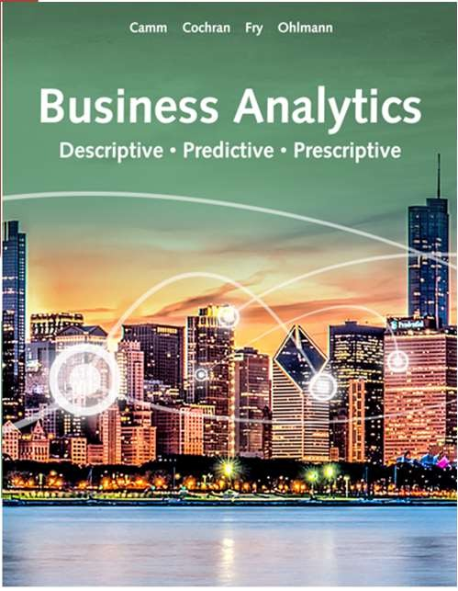

Business Analytics

Chapter 1

Camm, Cochran, Fry, Ohlman 4th Edition



What is Analytics??

“Using **Data** to apply the **Scientific Method** and make

**Better Decisions”**

Data Intelligence

* **Examine data sources, clean it, package it for analysis**

Business or

Data Analytics

* **Examines data for patterns, usability, modeling, improve business**

Data Scientist

* **Improve business, solutions, proposals, visualizations**



Explosive Growth!

1. Technological Advance
2. Methodology Advance
3. Computing Power & Storage Capability

◆ **Every Year** the world produces: 33 Zetabytes of Data!

1 Zetabyte = 10^21 bytes

1,000,000,000,000,000,000,000 = 1 million human brains



How To Do Business Analytics

1. **Decision Framework**
2. Data Infrastructure
3. Analytics Supply Chain
4. Data-Oriented Culture

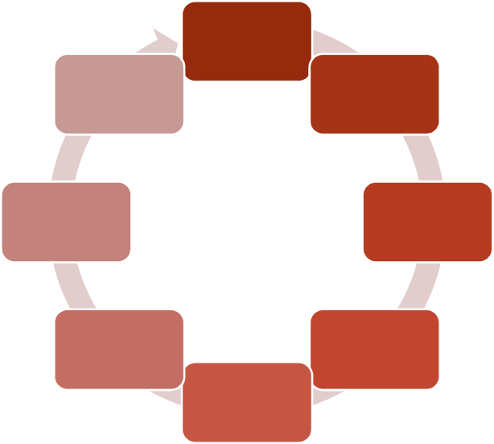

Compare Outcomes

Evaluate Likely Outcomes

Communicate Results

lternative

Possible A s

Determine

Implement Decisions

Determine Criteria

Evaluate

Define Problem

Decision Making Framework



Data Infrastructure Needs

Manage the Data

Understand the Data

Act on the Data

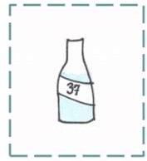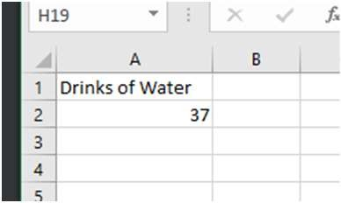

Data Questions

◆ Asking one question of our data

◆ Example:

**How many drinks of water were taken in our class over the last week?**

**What might the data look like?**

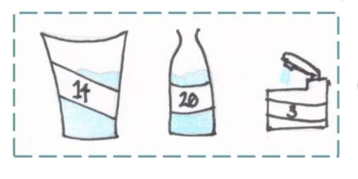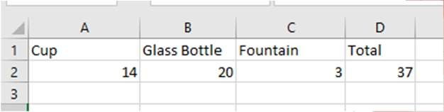

Adding Depth with Questions

◆ We can ask questions like:

◆ Who

◆ What

◆ When

◆ Why

◆ How

**What does the data look like if we ask how many drinks and what were they drunk from?**

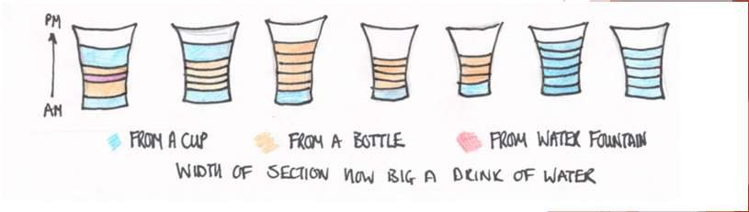

Even More Detail

◆ What does the data look like if we ask:

**How** many drinks**, what** was it drunk from**, what** size was the drink**, what** time of day was the drink**?**

**Do you notice any patterns?**

**What are some actions you may want to take after analyzing the data?**



Creating Questions

**Work with your group to discuss and write down other “depth” questions you could ask about drinks for the week**

**Current Questions**

◆ How many drinks?

◆ What was it drunk from?

◆ What time was it drunk?

◆ What day was it drunk on?

◆ What size was the drink?

**Other Examples**

◆ Where was it drunk?

◆ How was it drunk?

◆ How long did it take to drink?

◆ What was worn while drinking?

◆ What was happening when it was drunk?



Broader Analytics Supply Chain

Top Management

* Strategy Creation

**More Control**

**More Business Knowledge**

Operational Decision Makers

* Day-to-day process management
* Using information

Analysts

**Needs Data**

* Analytics
* Reporting
* Creating Information

**Has Data**

Data Engineers

**More Technical** • Gathering data and making it usable

* ETL- extract, transform, load
* Developers and Database Specialists

IT Professionals

* Data sources and IT infrastructure
* Data creation

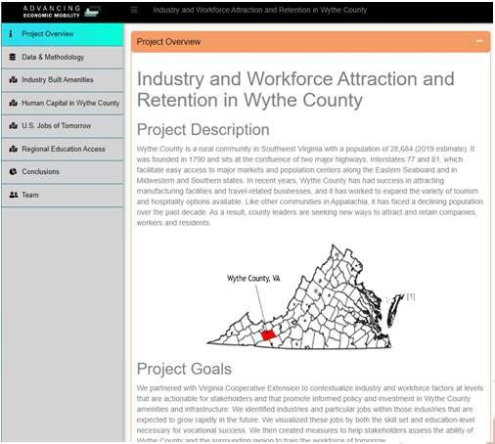

Descriptive Analytics

Encompasses the set of techniques that describes what has happened in the past; examples include:

◆ **Data Query -** A request for information with certain characteristics from a database.

◆ **Reports.**

◆ **Descriptive statistics.**

◆ **Data visualization (including data dashboards).**

◆ **Data-mining techniques –** patterns, relationships, cluster analysis, sentiment analysis

◆ **Basic what-if spreadsheet models.**

DSPG Data Dashboard

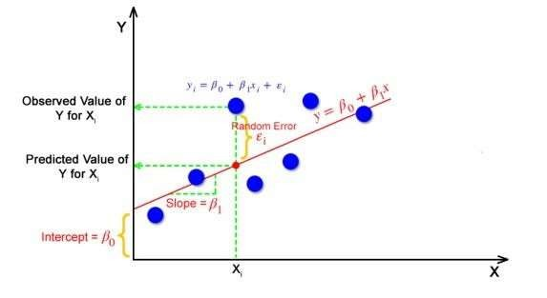

Predictive Analytics

Consists of techniques that use models constructed from past data to predict the future or ascertain the impact of one variable on another.

◆ **Example:**

◆ Survey data and purchase behavior used to predict the market share of a new product

◆ **Techniques:**

◆ Linear Regression

◆ Time Series Analysis

◆ Data Mining

◆ Simulation – probability and stats to construct computer models to study the impact of uncertainty on a decision

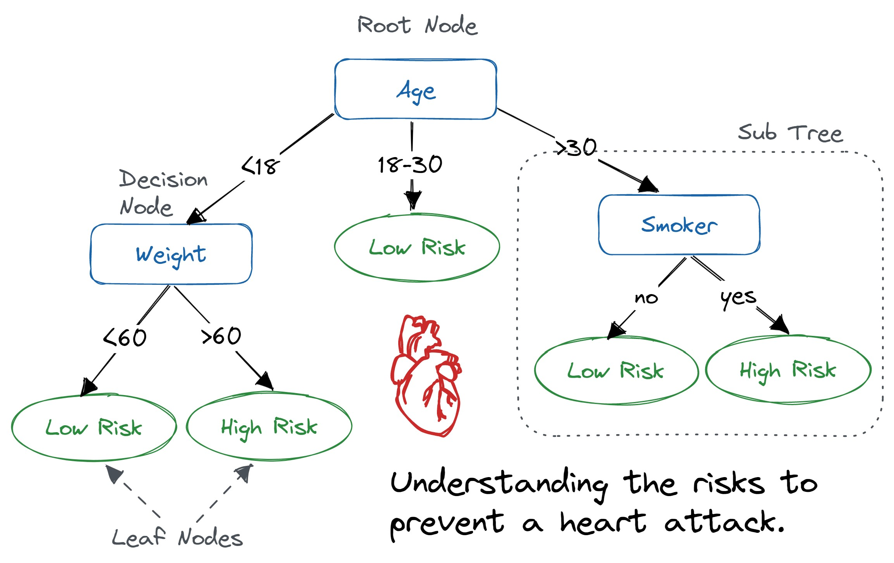

Prescriptive Analytics

Indicates a best course of action to take:

◆ **Examples**

◆ Optimization - Models that give the best decision subject to constraints of the situation.

◆ Decision Analysis - develop an optimal strategy, Employs **utility theory**

◆ Rule-Based Models

◆ Simulation - Combines the use of probability and statistics to model uncertainty with optimization techniques

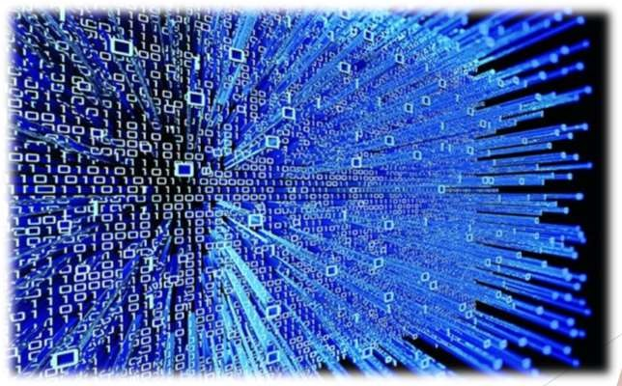

Big Data

Any set of data that is too large or too complex to be handled by standard data- processing techniques and typical desktop software.

◆ **The 4 V’s**

◆ Volume

◆ Velocity

◆ Variety

◆ Veracity

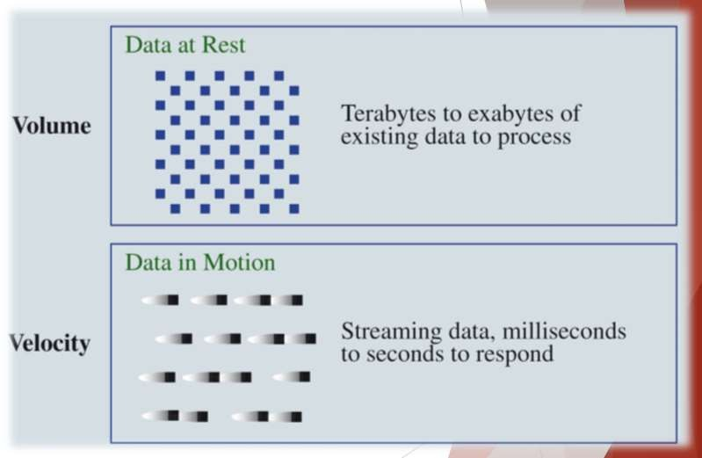

Big Data

◆ **Volume**

◆ Electronically collected => More Data

◆ Vast Storage

◆ **Velocity**

◆ Real-time capture

◆ Challenges:

◆ Storage

◆ Speed of Analysis

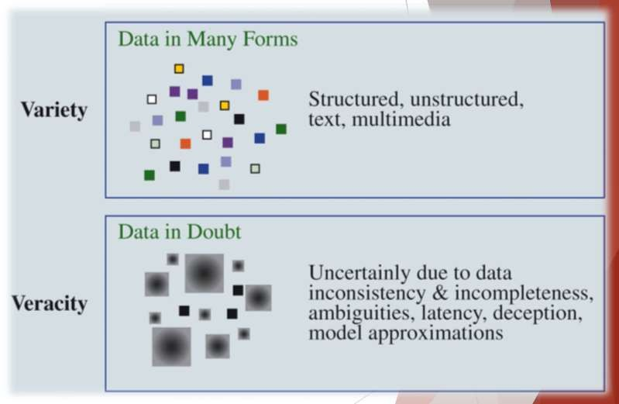

Big Data

◆ **Variety**

◆ More types of data

◆ Text, Audio, Video, ect…

◆ Great value to businesses

◆ More questions answered

◆ Complicated analysis

◆ More processing required

◆ **Veracity**

◆ How much uncertainty is in the data?

◆ Inconsistencies

◆ Different units of measure

◆ Lack of reliability

◆ Bias

**What about our # of drinks data?**

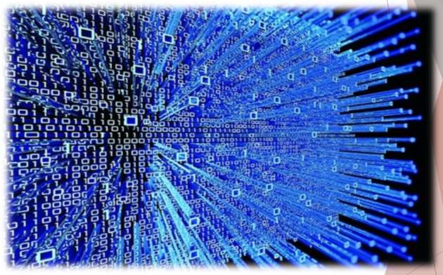

Big Data

◆ **The four Vs have led to:**

◆ New technologies:

◆ Hadoop

◆ MapReduce

◆ The Internet of Things (IoT)

◆ Data Security

◆ Increased demand for analysts and data scientists

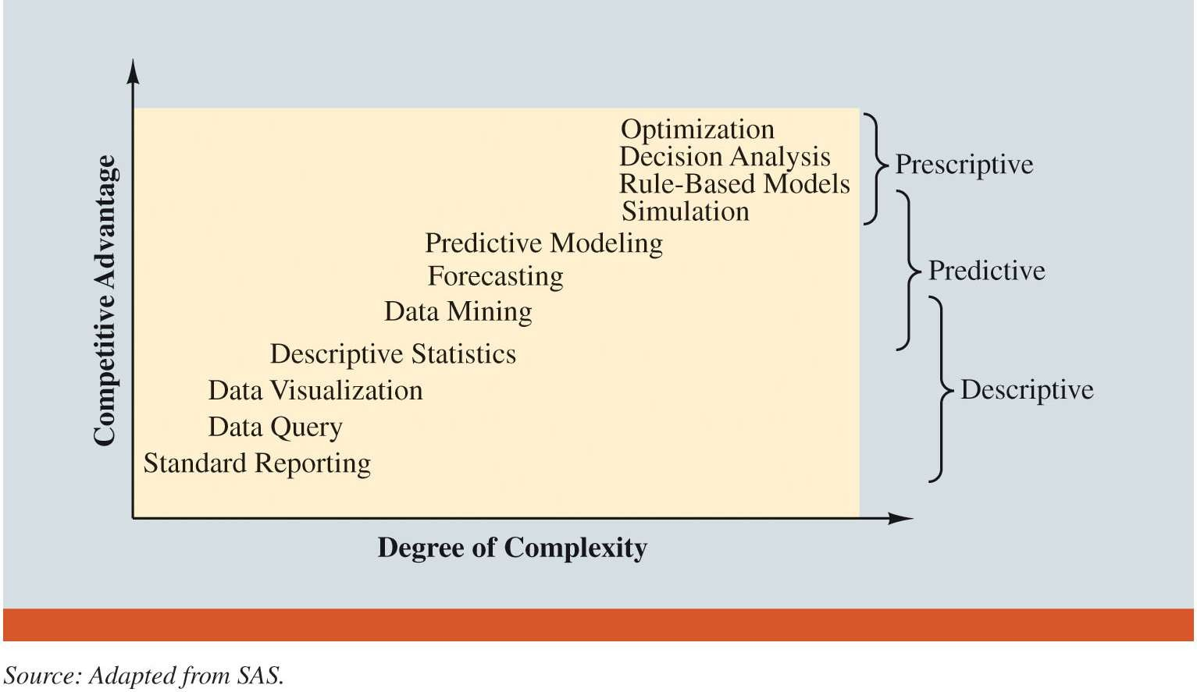

Spectrum of Business Analytics

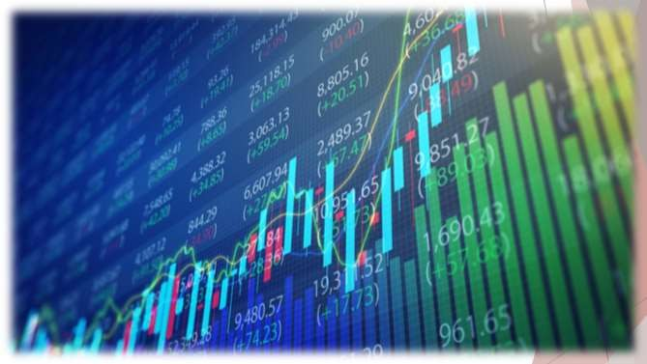

Business Analytics in Practice

◆ **Financial Analytics**

◆ Forecast financial performance.

◆ Assess the risk of investment portfolios and projects.

◆ Construct financial instruments such as derivatives.

◆ Construct optimal portfolios of investments.

◆ Allocate assets.

◆ Create optimal capital budgeting plans.

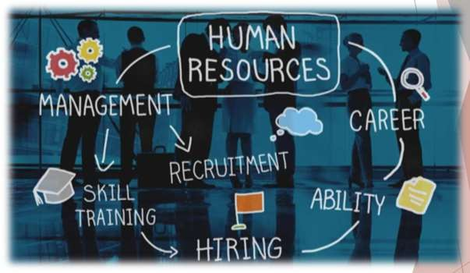

Business Analytics in Practice

◆ **Human Resource (HR) Analytics**

◆ New area of application

◆ Ensuring that the organization:

◆ Has the mix of skill sets necessary to meet its needs.

◆ Is hiring the highest-quality talent and providing an environment that retains it.

◆ Achieves its organizational diversity goals.

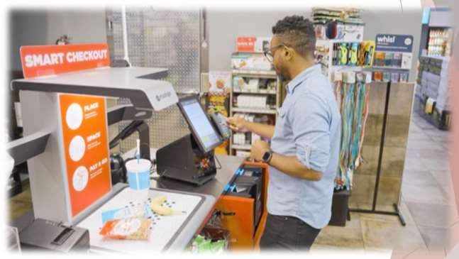

Marketing Analytics

◆ Understanding of consumer behavior:

◆ scanner data

◆ social media data

◆ Better understanding lead to:

◆ Better use of advertising budgets.

◆ More effective pricing strategies.

◆ Improved forecasting of demand.

◆ Improved product-line management.

◆ Increased customer satisfaction and loyalty.



Health Care Analytics

◆ Used to Improve:

◆ Patient, staff, and facility scheduling.

◆ Patient flow.

◆ Purchasing.

◆ Inventory control.

◆ Also used for:

◆ Diagnosis

◆ Treatment

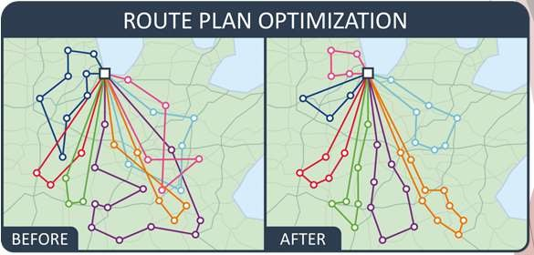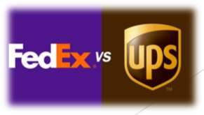

Supply Chain Analytics

◆ Higher Profits

◆ Efficient delivery of goods

◆ Optimal:

◆ Good Sorting

◆ Vehicle and Staff Scheduling

◆ Routing

◆ Better inventory and processing control

◆ Example:

◆ FedEx and UPS



Government and Nonprofit Analytics

◆ **Government**

◆ Drive out inefficiencies.

◆ Increase the effectiveness and accountability of programs.

◆ **Nonprofits**

◆ Ensure effectiveness and accountability to their donors and clients

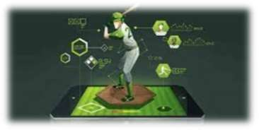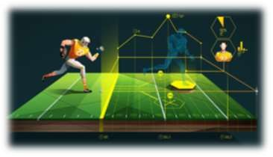

Sports Analytics

◆ Used to:

◆ Assess players for the amateur drafts.

◆ Decide how much to offer players in contract negotiations

◆ Optimize equipment designs

◆ Real-time player decisions

◆ Which pitchers to use in the playoffs

◆ Off-the-field business decisions

◆ Ticket Prices

Basketball Statistician

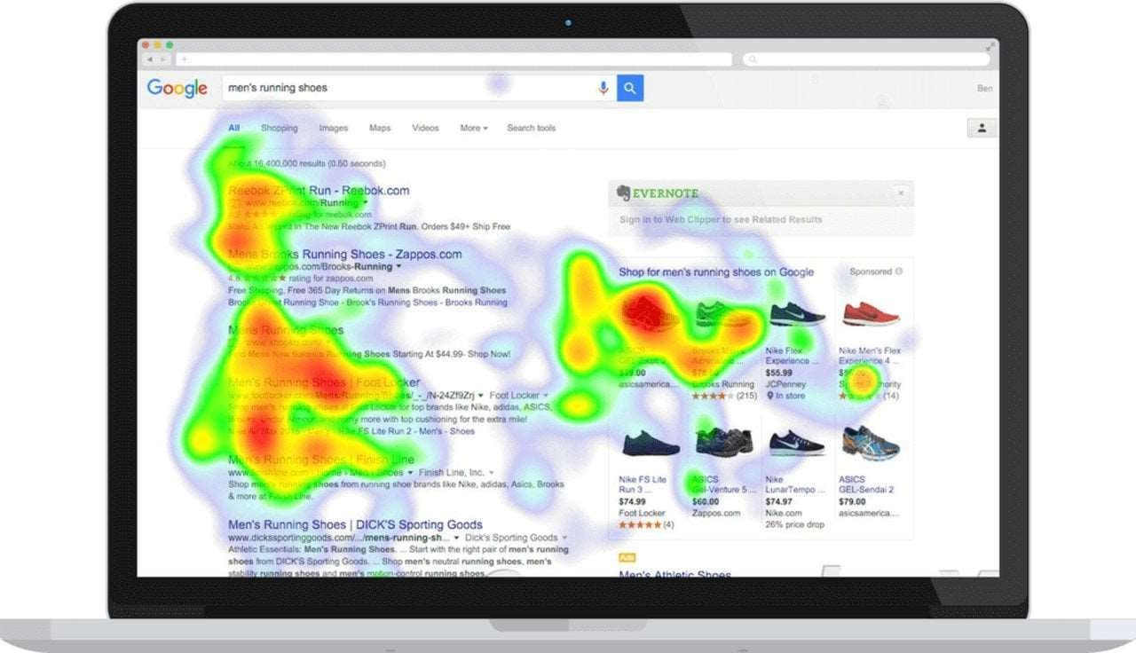

Web Analytics

◆ Used for:

◆ Analyzing web activity

◆ Website Visits

◆ Online Experiments

◆ A/B Testing

◆ Website configuration

◆ Position ads

◆ Promotional methods and content

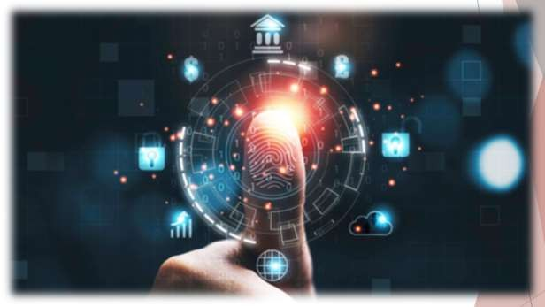

Legal and Ethical Issues in the Use of Data and Analytics

◆ Company obligation to protect data and not misuse it

◆ Example: Tracking, privacy, etc.

◆ Trade-off

◆ Risk vs. Reward for allowing use of data

◆ Written/Signed agreements

◆ Consumer & Company

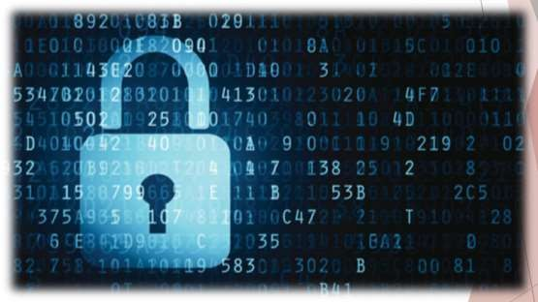

Legal and Ethical Issues in the Use of Data and Analytics

◆ **Privacy Law Example:**

◆ General Data Protection Regulation – EU May 2018

◆ Request for data easily understood and accessible

◆ Specified intended use

◆ Easily withdraw consent

◆ Individuals have right to a copy of their data and the right to demand it be erased

Legal and Ethical Issues in the Use of Data and Analytics



◆ **Analytics Professionals**

◆ Responsibility to behave ethically

◆ Protect Data

◆ Transparent about data and data collection

◆ Transparent about methods used to analyze data

◆ Specify assumptions in methodology

◆ Make valid conclusions

◆ Make understandable recommendations

◆ Ethical Guidelines American Statistical Association INFORMS